**BIO-DATA**

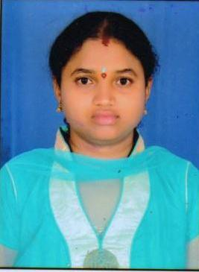

Designation : **Assistant Professor**

Department : ELECTRICAL & ELECTRONICS ENGINEERING

1. Name : LAVANYA NANDYALA
2. Date of Birth and Place of Birth : 09-03-1985
3. Address for Communication : D.No.12-4-3A, Sriram pet, Canal road

Palakol-534260,West Godavari District,

A.P,INDIA

1. Permanent Address : Same as above

5. Mobile No : +91-7893025726

1. Email-ID : nandu226@gmail.com
2. Educational Qualifications : M.Tech.,(Ph.D)

|  |  |  |  |  |
| --- | --- | --- | --- | --- |
| **Qualification** | **University/Board** | **Name of the College** | **Specialization** | **Year of Passing** |
| **Ph. D** | NIT | NIT,SILCHAR,ASSAM India | EEE | Pursuing |
| **PG** | JNTUK | NOVA ENGINEERING COLLEGE. Jangareddy Gudem, India | EEE | 2009 |
| **UG** | JNTU, Hyderabad | AGCET,  Tadepalli Gudem | EEE | 2007 |
| **Intermediate** | Board of intermediate Education | ADITYA, BVRM | MPC | 2003 |
| **X Class** | Board of Secondary Education | R.M.C School, Palakol, India | MPC | 2001 |
| **Others** |  |  |  |  |

1. Teaching /Industry Experience :

|  |  |  |  |
| --- | --- | --- | --- |
| **S No** | **Designation** | **Organization** | **Total Exp. Years and Months** |
| **1** | Assistant Professor | SCET(Autonomous), Narsapur | 2 years&  8 months |
| **2** | Assistant Professor | WISE, Nallajerla | 10 years |

1. Total Experience:

Teaching : 12.8 Years

Industry : NIL

1. Any other Distinctions/Achievements :
2. Research Papers Published in Journals :
3. Research Papers Published in Conferences :
4. Citations :
5. Workshops/STTP Attended : 10
6. Workshops Conducted :
7. Details of Research Projects :
8. Achievements :
9. Strengths : Commitment, Hard working
10. Other Details if any :

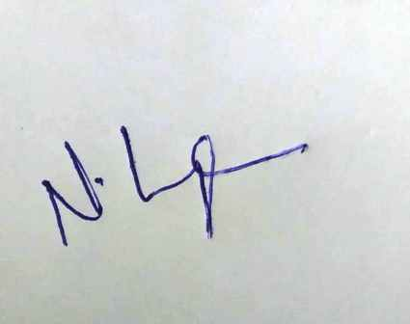

Signature of the Candidate