**BIO-DATA**

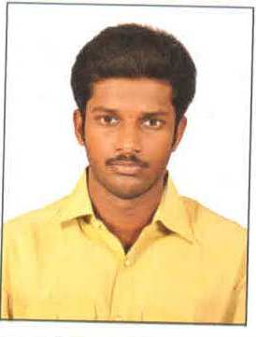

Designation : **ASSISTANT PROFESSOR**

Department : ELECTRICAL & ELECTRONICS ENGINEERING

1. Name : Mr. BANDARU BHARGAV SANTOSH
2. Date of Birth and Place of Birth : 04/01/1993
3. Address for Communication : 10-128,akanavarithota,mogalturmondal,

West Godavari Dt, A.P, India

1. Permanent Address : Same as above

5. Mobile No : +91-8106616267

1. Email-ID : bandarubhargavsantosh@gmail.com
2. Educational Qualifications : M.Tech

|  |  |  |  |  |
| --- | --- | --- | --- | --- |
| **Qualification** | **University/Board** | **Name of the College** | **Specialization** | **Year of Passing** |
| **PG** | JNTU K | SWARNANDHRA COLLEGE OF ENGG & TECH | PE&S | 2016 |
| **UG** | JNTU K | SWARNANDHRA COLLEGE OF ENGG & TECH | EEE | 2014 |
| **Inter** | INTER | SRI Gotham jr collage | MPC | 2010 |
| **X Class** | SSC | Viveka public school | - | 2008 |

1. Teaching /Industry Experience :

|  |  |  |  |
| --- | --- | --- | --- |
| **S No** | **Designation** | **Organization** | **Total Exp. Years and Months** |
| 1 | Asst professor | Swarnandhra College of Engineering & Technology | 4.5 Years |

1. Total Experience:

Teaching : 4.5 Years

Industry : 0

1. Any other Distinctions/Achievements :
2. Research Papers Published in Journals :
3. Research Papers Published in Conferences :
4. Citations : 00
5. Workshops/STTP Attended : 00
6. Workshops Conducted : 00
7. Details of Research Projects : 00
8. Achievements :
9. Strengths : 00
10. Other Details if any : 00

C:\Users\user\Downloads\WhatsApp Image 2021-03-02 at 12.14.18.jpeg

Signature of the Candidate