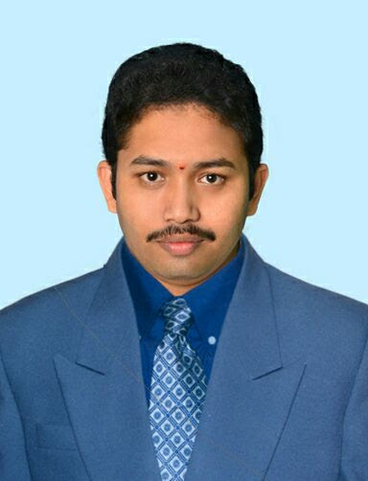**BIO-DATA**

Designation: Assistant Professor

Department : ELECTRICAL & ELECTRONICS ENGINEERING

1. Name : B. Subrahmanyam
2. Date of Birth and Place of Birth : 05-06-1990
3. Address for Communication : D.No:2-95,

Venkatrayapuram colony,

Near water tank, Ajjaram,

Peravali mandal-534331,

West Godavari District, A.P

1. Permanent Address : Same as above

5. Mobile No : +91-9000681169

1. Email-ID :subrahman9am@gmail.com
2. Educational Qualifications : M.Tech.

|  |  |  |  |  |
| --- | --- | --- | --- | --- |
| **Course** | **School/College** | **Board/University** | **Year of Passing** | **Marks Obtained (%)** |
| **M.Tech**  **(Power Electronics)** | Swarnandhra College Of Engineering & Technology, A.P | Jawaharlal Nehru Technological university.  (JNTU-Kakinada) | January  2016 | 84.22% |
| **B.Tech**  **(EEE)** | Rajamahendri Institute Of Engineering & Technology,  Rajahmundry. | Jawaharlal Nehru Technological university.  (JNTU-Kakinada) | 2012 | 78.00% |
| **D.EEE** | Smt. B. Seetha Polytechnic college, Bhimavaram. | State Board of Technical Education & Training,  Andhra Pradesh | 2008 | 66.20% |
| **S.S.C** | Red Rose Public School,  Peravali. | Board of Secondary Education,  Andhra Pradesh. | 2005 | 71.33% |

1. Teaching /Industry Experience :

|  |  |  |  |
| --- | --- | --- | --- |
| **S No** | **Designation** | **Organization** | **Total Exp. Years and Months** |
| **1** | Assistant Professor | Swarnandhra college of Engineering and Technology,(Autonomous ) NARASAPUR | 8.2 Years |

1. Total Experience:

Teaching : 8.2 years

1. Research Papers Published in Journals : 01
2. Research Papers Published in Conferences : 01
3. Workshops/STTP Attended : 04
4. Workshops Conducted : 01
5. Strengths : Flexibility, **Dedication, Continuous Learning, Creativity**



Signature of the Candidate