Swarnandhra College of Engineering & Technology
(Autonomous)
Seetharampuram, NARSAPUR, W.G. Dt., 534 280.
Department of Mathematics
DISCRETE MATHEMATICS(19CS3T01)
Question Bank (R-19)
Unit 1: Mathematical logic
- Rewrite the following statement without using the conditional and also symbolize the same: “If I dream of home, then I will work hard and earn money”.
- (a)Write each of the following sentences symbolically
i) It is not hot but it is sunny. ii) It is neither hot nor sunny.
(b) Let p, q, r be the propositions
p: You have the flu
q: You miss the final examination
r: You pass the course
Write the following propositions into English sentences
1. p→q 2. ¬ p→r 3. q→¬ r 4. pvqvr 5. (p→¬ r)v(q→¬ r)
- i) Define converse, contrapositive and inverse of an implication with example.
ii) Write inverse and contrapositive of the following conditional statement.
“If a real number x² is greater than zero, then x is not equal to zero”.
- Write converse and inverse of the following conditional statement
“If a triangle is not isosceles then it is not equilateral”.
- Let p and q be the propositions
p: You drive over 65 miles per hour
q: You get a speeding ticket
Write these propositions using p and q and logical connectives.
(a) You do not drive over 65 miles per hour.
(b) You drive over 65 miles per hour, but you do not get a speeding ticket.
(c) You will get a speeding ticket, if you drive over 65 miles per hour.
(d) If do not drive over 65 miles per hour, then you will not get a speeding ticket.
(e) Drive over 65 miles per hour is sufficient for getting a speeding ticket.
- (a)Without constructing truth table, Prove that $\left(p→q\right)→q⟺\left(p∨q\right).$
(b) State De Morgan’s Laws. Show that (P→Q) is logically equivalent to (¬PVQ).
- Construct truth table for following formulae, (a) (QΛ (P→Q)) →P (b) ¬ (PV(QΛR)) ↔ ((PVQ) Λ (PVR)) (c) (P↔R) Λ(¬ Q →S) (d) ((P→(Q→R)) →((P→Q) →(P→R)))
- Prove that (¬ PΛ (¬ Q Λ R)) V (Q Λ R) V(P Λ R)$⟺$ R without using truth table.
- Verify whether the two statements (PVQ→R) and (¬ R→¬ (PVQ)) are logically equivalent or not.
- (a) Define well formed formula. Explain Tautology by an example.
(b) Prove that (((P∨$\sim$Q) → R)$→$S) ∨ $\sim$(((P∨$\sim$Q)→R)$→$S) is a tautology.
(c) Prove that NAND and NOR are commutative but not associative.
(d) Define NAND, NOR and Exclusive OR with truth tables.
(e) Show that$(A⨁B)∨(AB)AB$.
- Define Principle disjunctive normal form and Show that the Principle disjunctive normal form of
pv(¬ p→ (qv(¬ q→r))) is ∑(1,2,3,4,5,6,7)
- Define Principle conjunctive normal form and Show that the Principle conjunctive normal form of (p→(qΛr)) Λ (¬ p→(¬qΛ¬ r)) is 𝝅 (1,2,3,4,5,6)
- Without constructing truth table, obtain the Principle conjunctive normal form of (p→(qΛr)) Λ (¬ p→(¬qΛ¬ r))
- Obtain PDNF of (PΛQ) V(¬ PΛR) V(QΛR) and hence deduce PCNF.
- Obtain Principal disjunctive normal form of (¬ P) VQ.
- Prove or disprove the validity of the following arguments:
(i)If a baby is hungry, then the baby cries. If the baby is not mad, then he does not cry. If a baby is mad, then he has a red face. Therefore, if a baby is hungry, then he has a red face.
(ii) If the client is guilty, then he was at the scene of the crime. The client was not at the scene of the crime. Hence, the client is not guilty.

- Verify that the following argument is valid by using the rule of inference.
(i)If Joe is a mathematician, then he is ambitious.
If Joe is an early riser, then he does not like oatmeal.
If Joe is ambitious, then he is an early riser.
Hence, if Joe is a mathematician, then he does not like oatmeal. (ii) If Clifton does not live in France, then he does not speak French.
Clifton does not drive a Datsun.
If Clifton lives in France, then he rides a bicycle.
Either Clifton speaks French, or he drives a Datsun.
Hence, Clifton rides a bicycle.
- Show that the following premises are inconsistent
“If Jack misses many classes through illness, then he fails high school. If Jack fails high school, then he is uneducated. If Jack reads a lot of books, then he is not uneducated. Jack misses many classes through illness and reads a lot of books”.
- (a)Establish the validity of the following argument¬ (p Λ¬ q), ¬ q v r, ¬ r $⟹$ ¬ p
(b)Show that R Λ (PVQ) is a valid conclusion from the premises PVQ, Q→R, P→M, ¬M.
(c)Show that P→S can be derived from ¬ PVQ, ¬ QVR, R→S.
- (a )Using indirect proof method prove P→¬S is a valid argument from P→(QVR), Q→¬ R, S→¬R, P.
(b)By indirect proof show that P→Q, Q→R, ¬ (P Λ R), PVR $⟹$ R
Unit 2: Recurrence relations
- Explain the methods of solving Recurrence relations with suitable examples.
- Solve the recurrence relation using substitution method
(i)a_{n} = a_{n-1}+ f(n) for n
(ii)a_{n} = c a_{n-1} + f(n) for n
(iii) a_{n} = 2a_{n/2}+ (n-1) for n >2 where a₁=0
(iv) a_{n} = a_{n-1} + n(n-1), where a₀=1
- Write a generating function for $a_{n}$, the number of ways of obtaining the sum n when tossing 9 distinguishable dice. Then find $a_{25}$.
- Using Generating function solves the recurrence relation
(a) a_{n}-7a_{n-1}+10a_{n-2}=0 for n≥2 with a₀=10, a₁=41.
(b) a_{n}-6a_{n-1}+12a_{n-2}-8a_{n-3}=0, n≥3.
(c) a_{n}-7a_{n-1}+26a_{n-2}-24a_{n-3} = 0 for n≥3.
(d) a_{n}-9a_{n-1}+27a_{n-2}-27a_{n-3} = 0 for n≥3.
(e) T(k)-9T(k-1)+26T(k-2)-24T(k-3)=0, for k≥3 with T(0)=0,T(1)=1,T(2)=10.
- Solve the recurrence relation F_{n}= F_{n-1}+F_{n-2,} n≥2 with F₀ =0, F₁=1.
- Solve the recurrence relation using characterstic root equation method (a)$a_{n}+2a_{n-1}-3a_{n-2}={4n}^{2}-5 where n≥2$
(b)$a_{n}-4a_{n}+3a_{n}=-200,$ $n≥0,$given $a_{0}=3000, { a}_{1}=3300$.
- Solve the recurrence relation
(a) S (k)-3S (k-1)-4S (k-2) =4^{k}, k≥2.
(b) $u_{n+2}+3u_{n+1}+2u_{n}=3^{n},$ for $n≥0,$given $u_{0}=0, { u}_{1}=1$ .
(c) $a_{n}-{3a}_{n-1}=5X3^{n} where n≥1 and where a_{0}=2$.
(d) $a_{n}-{5a}_{n-1}+6a_{n-2}=3\left(n-1\right) where n≥2 and where a_{0}=1, a_{1}=5$.
(e) $a_{n}-{7a}_{n-1}+10a_{n-2}=4^{n} where n≥2 and where a_{0}=8, { a}_{1}=36$.
(f) $a_{n+1}=ka_{n}$ for $n≥1$ and $a_{3}=\frac{153}{49}$ and $a_{5}=\frac{1377}{2401}$.
- Solve the recurrence relation
(a) a_{n+2}²-5a_{n+1}²+6a_{n}²=7n, a₀ =1, a₁ =1.
(b) ${a^{2}}_{n}-{{2a}_{n-1}}^{2}=1 ,n≥1for where a_{0}=2$.
(c) $a_{n}=\sqrt{\frac{a_{n-2}}{a_{n-1}}}$ with initial conditions $a_{0}=8, { a}_{1}=\frac{1}{2\sqrt{2}}$ .
- (a)Determine the coefficient of $x^{5}$ in ${(1-2x)}^{-7}$.
(b)Find coefficient of $x^{27}$in ${(x^{4}+{2x}^{5}+3x^{6}+---)}^{5}$.

Unit 3: Set theory and Relations
- Explain about the following properties of a binary relation in a set X .Give an example of each
i) Reflexive ii) symmetric iii) transitive iv) irreflexive v) Anti symmetric.
- Give one example of a relation which is transitive but not reflexive.
- (a)What are the properties of the relation
and also write R as a set.
(b)Let A = {1,2,3,4} and R = {(1,1), (1,2), (1,3), (2,1),(2,2),(2,3),(3,1),(3,2),(3,3),(4,4)}.Is R is an
equivalence relation? If yes, then find the partition of A induced by R.
- Define equivalence relation with an example? Let
be a relation on X,
Show that R is an Equivalence relation on X.
- a) Let the relation on the set {1, 2, 3}. Find the transitive closure of R.
(b) If A = { 1, 2, 3, 4} and R is a relation on A defined by
R = { (1, 2), (1, 3), (2, 4), (3, 2), (3,3), (3, 4) } . Find $R^{2} and R^{3}$ . Write down their Digraphs.
- Given S= { 1, 2, 3, 4 } and relation R on S defined by R= { (1, 2), (4, 3), (2, 2 ), (2, 1), (3,1) }
Show that R is not transitive .Find a relation ${ R}_{1}⊇R$ such that $R_{1}$ is transitive . Can you
find another relation $R_{2}⊇R$ which is also transitive?
- A relation R defined over the set of integers Z as aRb=a-b is a multiple of n. Show that R is an
Equivalence relation.
- Define Equivalence Relation. Let A={1,2,3,4} and R={(1,1), (1,2), (2,1), (2,2), (3,1), (3,3),(1,3),(4,1),
(4,4)} be a relation on A, Is R an Equivalance relation?
- Find M_{SOR},$M_{\tilde{R}}$,$M_{\tilde{S}}$, $M_{S\tilde{O}R}$ and show that $M_{S\tilde{O}R}$= $M_{\tilde{R}O\tilde{S}}$
$M_{R}=\left[\begin{matrix}1 & 0 & 1 \\ 1 & 1 & 0 \\ 1 & 1 & 1\end{matrix}\right]$ ; $M_{S}=\left[\begin{matrix}1 & 0 & \begin{matrix}0 & 1 & 0\end{matrix} \\ 1 & 0 & \begin{matrix}1 & 0 & 1\end{matrix} \\ 0 & 1 & \begin{matrix}0 & 1 & 0\end{matrix}\end{matrix}\right]$
- Prove that the relation “Congruene modulo m” given by R= {(x, y) / x-y is divisible by m} over the set
of Positive integers is an Equivalence relation.
Show also that if x₁ ≡ y₁ and x₂ ≡ y₂, then (x₁+x₂) ≡(y₁+y₂).
11. What is a compatibility relation? Let the compatibility relation on a set
be given by the following matrices
- (ii)
Draw the graph and find the maximal compatibility blocks of the relation.
12. (a) Define a Poset and Draw the Hasse diagrams of the following Posets
i) Where
ii) Where “/” : divides
b) Let A={1, 2, 3, 4, 6, 8, 12, 24} and the relation R is defined as R={(a,b)/a ϵA divides b ϵA} Prove that R
is Partial order relation. Also draw the Hasse diagram.
c) Let A={1, 2, 3, 4, 6, 12} and the relation R is defined as R={(a,b)/a ϵA divides b ϵA} Prove that R is
Partial order relation. Also draw the Hasse diagram
d) Define POSET. Prove that the set of positive divisors of 36 is a POSET and draw the Hasse diagram.
e) In the following case consider a partial order of divisibility on the set A. draw the Hasse diagram for
the Poset and determine whether the poset is totally ordered or not. A={1, 2, 3, 6, 10, 15, 30}
13. (a) Determine the number of primes not exceeding 100 and not divisible by 2,3,5 or 7?
(b) If there are 200 faculty members that speak French, 50 that speakRassian, 100 that speak Spanish, 20 that speak French and Russian, 60 that speak French and Spanish, 35 that speak Russian and Spanish, while only 10 speak French, Russian, and Spanish, how many speak either French or Russian or Spanish?
14. (a) Define pigeonhole principle and generalized pigeonhole principle?
(b) Show that in a group of 367 people there must be atleast one pair with same birthday.
Unit 4: Graph theory
1. a) What is the largest possible number of vertices in a graph with 35 edges and all Vertices of degree
at least 3.
b) Is the sequences d = ( 1,2,3,4,4,5,6,7 ) is Graphic?
2. a) Define the following and give one example each i) Sub graph ii) Spanning Sub graph iii) Induced
Sub graph iv) Simple Graph v) Multi Graph
b) State first theorem of Graph theory and Show that in any graph there are even number of odd degree
Vertices.
3. a) Define Graph Isomorphism. Write the necessary and sufficient conditions for existence of isomorphism
between two graphs
b) What are the any two ways of representing a graph in computer memory with examples?
(or) Explain and give suitable examples (i) Adjacency matrix of simple graph and directed graph
(ii) Incidence matrix of simple graph and directed graph
4. Define the following Special Graphs (i) Complete Graph (ii) Cycle Graph (iii) Path Graph
(iv) Bipartite Graph (v) Complete Bi-partite vi) complement of a graph with examples
5. Define the terms a) Euler path, Euler Circuit & Eulerian graph b) Hamiltonian path, Hamiltonian
Cycle and Hamiltonian graph with example.
6. a) Explain the difference between a circuit and cycle in graphs.
b) Explain the difference between Eulerian graphs and Hamiltonian graphs.
7. a) Give an example for graph having Eulerian and Hamiltonian circuits.
b) Write the Rules for constructing Hamilton paths and cycles .
8. Show that the following graphs are isomorphic or not.
a)
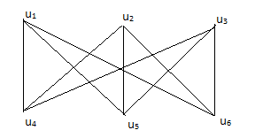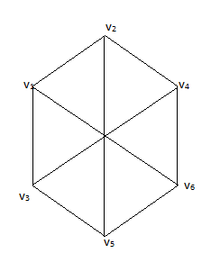
G₁ G₂
b)
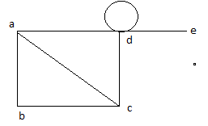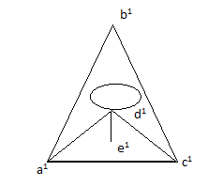
c) G₁ G₂
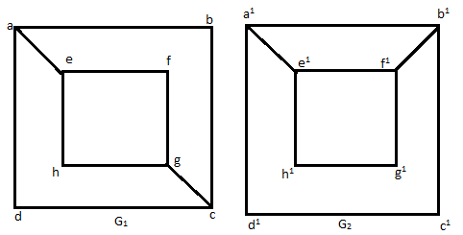
d)
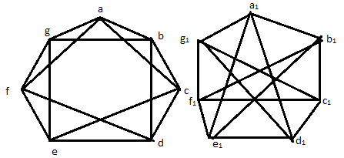
9) Find the Euler paths, circuits if exists of the following graphs.
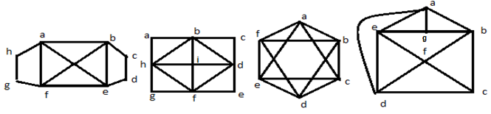
10) Find the Hamiltonian paths, circuits if exists of the following graphs.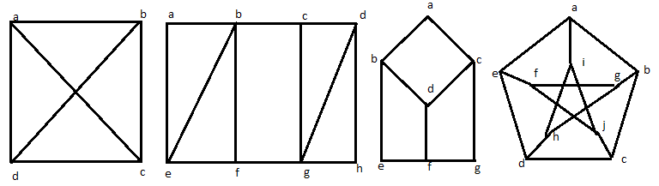
Unit 5: Trees
- a) Define a planar Graph with examples.
b) Show that complete graph $K_{5}, complete bipartite graph K_{3,3}$ are non planar.
- Define Chromatic Number. Find the Order, Size, and Chromatic Number of the following Graphs $i.K_{n }, ii. K_{m,n} iii. C_{n} iv. P_{n }v. W_{n} vi N_{n } vii. T_{n}$
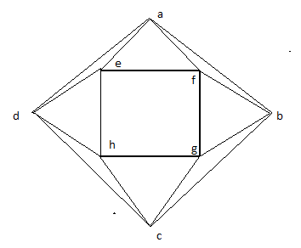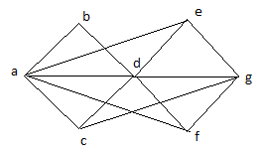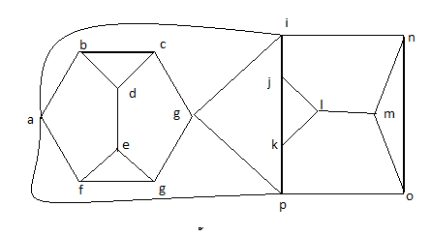
- a) Draw the non directed different trees on 6 vertices
b) Write a kruskal’s algorithm with an example
- a) Define i) Tree ii) Spanning Tree iii) Minimal Spanning Tree iv) Weighted graph with examples.
b) Write Prim’s algorithm with an example.
- a) Define Binary tree, complete binary tree, regular binary tree and tree trasversals with examples.
b) Draw all regular binary trees i) with exactly 7 vertices ii) with exactly 9 vertices.
- Explain BFS and DFS algorithms with an example.
- a) Draw the spanning tree for the following graphs using BFS Algorithm.
b) Draw the spanning tree for the following graphs using DFS Algorithms.
(i) (ii)
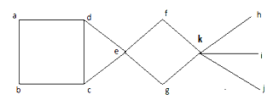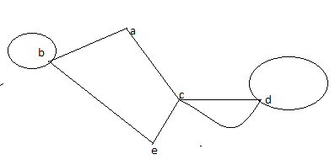
(iii)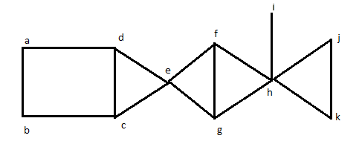(iv)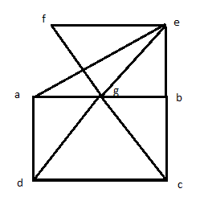
- a) Determine the cost of minimum spanning tree by using kruskal’s algorithm
b) Determine the cost of minimum spanning tree by using prims’s algorithm
