**BIO-DATA**

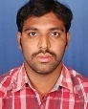Designation: **Assistant Professor**

Department: **COMPUTER SCIENCE AND ENGINEERING**

1. Name : Mr. JOHNPAUL KOSANAMA
2. Date of Birth and Place of Birth :30.07.1986
3. Address for Communication : NUZVID
4. Permanent Address : NEHRU PETA, NUZVID, KRISHNA DT-521201

5. Mobile No : 9492289701

1. Email-ID : chinni518@gmail.com
2. Educational Qualifications : B.Tech, M.Tech,

|  |  |  |  |  |
| --- | --- | --- | --- | --- |
| **Qualification** | **University/Board** | **Name of the College** | **Specialization** | **Year of Passing** |
| **PG** | JNTUK | Nova college of Engineering & Technology | Computer Science and Engineering | 2011 |
| **UG** | JNTU | Sri Saradhi Institute of Engineering and Technology | Computer Science and Engineering | 2007 |
| **Intermediate** | Board Of Intermediate, | St. Ann’s Jr.College | MPC | 2003 |
| **SSC** | SSC Board | St. Ann’s English Medium High School |  | 2001 |

1. Teaching/Industry Experience :

|  |  |  |  |
| --- | --- | --- | --- |
| **S No** | **Designation** | **Organization** | **Total Exp. Years and Months** |
| **1** | Assistant Professor | Swarnandhra college of Engineering and Technology, (Autonomous), Narsapur. | 1 Months |
| **2** | Assistant Professor | Nova College of Engineering Technology, Jangareddygudem | 10 Years |

1. Total Experience : 10.1 Years

Teaching : 10.1 Years

Industry :

1. Any other Distinctions/Achievements :
2. Research Papers Published in Journals : 09
3. Research Papers Published in Conferences :
4. Citations : Nil
5. Workshops/STTP Attended : 02
6. Workshops Conducted : 00
7. Details of Research Projects : Nil
8. Achievements :
9. 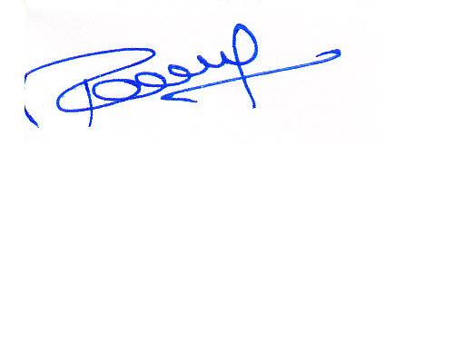Strengths : Hardworking, Commitment.
10. Other Details if any :

Signature of the Candidate