**BIO-DATA**

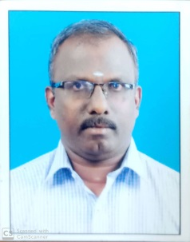

Designation : **Professor**

Department : **COMPUTER SCIENCE AND ENGINEERING**

1. Name : Dr. A.Jegatheesan
2. Date of Birth and Place of Birth : 31-07-1975
3. Address for Communication : Professor, CSE Dept., Swarnandhra College of engineering and

Technology, Narsapur

1. Permanent Address : South Anjukudiyiruppu, Thengamputhur (P.O), Kanyakumari

District, Tamilnadu, 629602

5. Mobile No : 9865640964

1. Email-ID : jegatheese[@gmail.com](mailto:allakagopichand@gmail.com)
2. Educational Qualifications : B.E,M.E,Ph.D

|  |  |  |  |  |
| --- | --- | --- | --- | --- |
| **Qualification** | **University/Board** | **Name of the College** | **Specialization** | **Year of Passing** |
| **Ph. D** | Anna University  Chennai |  | Information and  Communication  Engineering | 2015 |
| **PG** | Madurai Kamaraj  University | Arulmigu Kalasalingam College of Engineering, Srivilliputhur, Tamilnadu | Computer  Science and  Engineering | 1999 |
| **UG** | Manonmaniam  Sundaranar University | National Engineering College, Kovilpatti, Tamilnadu | Computer  Science and  Engineering | 1996 |
| **Intermediate** | State Board, Tamilnadu | LMPC Hr. Sec. School,  Puthalam | MPC | 1992 |
| **X Class** | State Board, Tamilnadu | Govt. High School,  Thengamputhur | General | 1990 |
| **Others** |  |  |  |  |

1. Teaching /Industry Experience :

|  |  |  |  |
| --- | --- | --- | --- |
| **S No** | **Designation** | **Organization** | **Total Exp. Years and Months** |
| **1** | Associate Professor | Sree Buddha Engineering College, Alappuzha,  Kerala | 2 years  2 months |
| **2** | Assistant Professor | Cape Institute of Technology, Levengipuram,  Tirunelveli, Tamilnadu | 11 years  8 months |
| **3** | Assistant Professor | Noorul Islam College of Engineering, Thuckaly,  Kanyakumari, Tamilnadu | 5 years  10 months |
| **4** | Lecturer | The Indian Engineering College, Tirunelveli,  Tamilnadu | 2 years |

1. Total Experience:

Teaching : 20 Years

Industry : nil

1. Any other Distinctions/Achievements : nil
2. Research Papers Published in Journals : 08
3. Research Papers Published in Conferences : 16
4. Citations : 06
5. Workshops/STTP Attended : 34
6. Workshops Conducted : 10
7. Details of Research Projects : nil
8. Achievements : nil
9. Strengths : Hard working
10. Other Details if any : 4 patents and 1 book chapter published

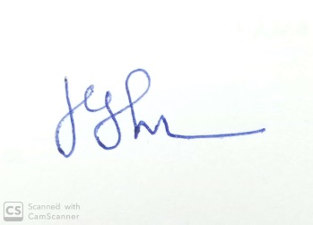

Signature of the Candidate