**BIO-DATA**

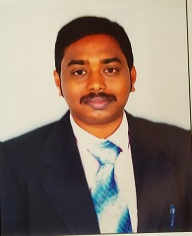Designation: ASSISTANT PROFESSOR

Department :**COMPUTER SCIENCE AND ENGINEERINGP**

1. Name : Mr. EDA SAMUEL RAJU
2. Date of Birth and PlaceofBirth :29-06-1991
3. AddressforCommunication : Old Navarasapuram, Y V Lanka Post, Narsapur,W.G.Dt
4. PermanentAddress : Old Navarasapuram, Y V Lanka Post, Narsapur,W.G.Dt
5. 5. MobileNo :8008694690
6. Email-ID :[samuelrajueda@gmail.com](mailto:samuelrajueda@gmail.com)
7. EducationalQualifications :M.Tech

|  |  |  |  |  |
| --- | --- | --- | --- | --- |
| **Qualification** | **University/Board** | **Name of the College** | **Specialization** | **Year of Passing** |
| **PG** | JNT University, kakinada | D.N.R college of Engineering and Technology | CSE | 2016 |
| **UG** | JNTUH | Swarnandhra Institute of Engineering and Technology | IT | 2013 |
| **X Class** | Board of Secondary Education |  | ------- |  |
| **Others** |  |  |  |  |

1. Teaching/IndustryExperience :

|  |  |  |  |
| --- | --- | --- | --- |
| **S No** | **Designation** | **Organization** | **Total Exp. Years and Months** |
| **1** | ASSISTANT PROFFESOR | Swarnandhra College of Engineering and Technology , Seetharamapuram | 1.6 year |
| **2** | Jr Java Developer | Apita Software Solutions, Hyderabad | 1 year |
| **3** | Technical Support | Al-Rawabi Group of Companies | 2 years |

1. TotalExperience:

Teaching :1.6 year

Industry :3 years

1. AnyotherDistinctions/Achievements :
2. Research Papers PublishedinJournals :
3. Research Papers PublishedinConferences:
4. Citations: 0
5. Workshops/STTPAttended:
6. WorkshopsConducted : 00
7. Details ofResearchProjects :---
8. Achievements : --
9. 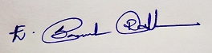Strengths :
10. Other Detailsifany :

Signature of the Candidate