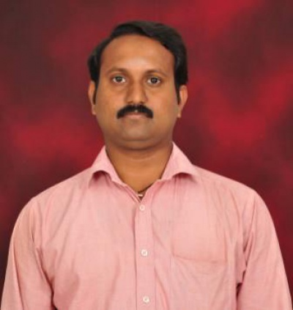
BIO-ATA

Designation : Assistant Professor

Department : COMPUTER SCIENCE AND ENGINEERING

- Name : Mr.K.Prabhakar
- Date of Birth and PlaceofBirth :01-07-1987
- AddressforCommunication : SCET Boys Hostel,Seetharampuram
- PermanentAddress : 21/7A,Puthen Veedu,Chellamkonam,K.K.Dist,Tamilnadu.
5. MobileNo :8688513935
- Email-ID :prabhakarswrn@gmail.com
- EducationalQualifications :B.Tech.,M.E

Qualification | University/Board | Name of the College | Specialization | Year of Passing
PG | Anna University of Technology, Trichy. | M.I.E.T Engineering College,Trichy,Tamilnadu | Computer Science and Engineering | 2011
UG | Anna University, Chennai. | Noorul Islam college of Engineering,kumaracoil,  Kanyakumari Dist,Tamilnadu | Information  Technology | 2008
Intermediate | State Board,Tamilnadu | Govt.Higher Secondry School,Thuckalay,  Kanyakumari Dist, Tamilnadu | MPC | 2004
X Class | State Board,Tamilnadu | Govt.Higher Secondry School,Thuckalay,  Kanyakumari Dist, Tamilnadu | General | 2002
Others

- Teaching/IndustryExperience :

S No | Designation | Organization | Total Exp. Years and Months
1 | Assistant Professor | Swarnandhra college of Engineering and Technology,(Autonomous ),Narasapur | 1 Year  8 Months
2 | Assistant Professor | Vivekananda college of Engineering for Women, Tiruchengode. | 7 Years  10Months
3 | Programmer | Regional Transport Office, Thiruverambur,Trichy | 6 Months

- Total Experience : 10 Years
Teaching : 9.8 Years
Industry : 6 Months
- Any other Distinctions/Achievements : AICTE Ambassador for Smart India Hackathon 2017.
- Research Papers Published in Journals : 06
- Research Papers Published in Conferences : 06
- Citations : Nil
- Workshops/STTPAttended : 42
- Workshops Conducted : 03
- Details of ResearchProjects : Nil
- Achievements : Golden Guru Award in 2017 from TATA Gold
- Strengths : Commitment, Hardworking
- Other Details ifany :

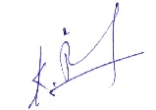
Signature of the Candidate

