BIO-DATA

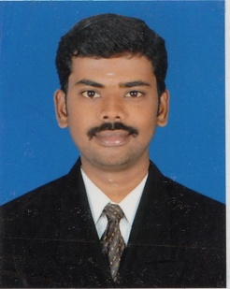
Designation: Assistant Professor

Department: COMPUTER SCIENCE AND ENGINEERING

- Name : Mr.P.PRAKASH
- Date of Birth and Place of Birth :15-02-1987
- Address for Communication :2nd Street - VIP Garden,Solar, Erode,Tamil Nadu
- Permanent Address : 2nd Street - VIP Garden,Solar, Erode,Tamil Nadu
5. Mobile No : Modakurchi (TP),Erode,Tmailnad
- Email-ID : +91-9751115660
- Educational Qualifications : M.Tech,

Qualification | University/Board | Name of the College | Specialization | Year of Passing
PG | ANNA UNIVERSITY | Velalar College Of Engineering and Technology. Thindal | Computer Science and Engineering | 2013
UG | ANNA UNIVERSITY | Velalar College Of Engineering and Technology | Information and Communication engineering | 2008
Diploma | Board Of Technical education,Tamilnadu | Kongu polytechnic college,Tmailnadu | Electronics and communication Engineering | 2005
SSC | SSC Board,Tamil nadu | D J HSS School | ---- | 2002

- Teaching/Industry Experience :

S No | Designation | Organization | Total Exp. Years and Months
1 | Assistant Professor | Swarnandhra college of Engineering and Technology, (Autonomous), Narsapur. | 1year.9months
2 | Assistant Professor | Vidyaa Vikas College of Engineering & Technology, Tiruchnegode. | 3 years
3 | Assistant Professor | Karur College of Engineering,  Karur | 1 year
4 | Assistant Professor | Vivekanandha College of Technology for Women, Tiruchengode | 1.5 years

- Total Experience : 7 years
Teaching : 7 years
Industry :
- Any other Distinctions/Achievements :
- Research Papers Published in Journals : 2
- Research Papers Published in Conferences : 3
- Citations :
- Workshops/STTP Attended : 8
- Workshops Conducted :
- Details of Research Projects :
- Achievements :
- Strengths :
- Other Details if any :


Signature of the Candidate

