BIO-DATA

Designation: Assistant Professor

Department: COMPUTER SCIENCE AND ENGINEERING 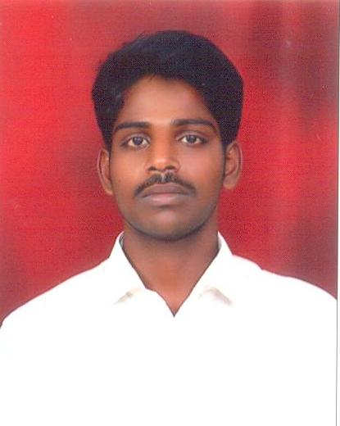

- Name : Mr.S.SYED FARMHAN
- Date of Birth and Place of Birth :17-12-1987
- Address for Communication :Tamil Nadu
- Permanent Address : B.Thurinjipatti(po),Pappiredippatti(tk),Dharmapuri(dt)
5. Mobile No : 9445390331
- Email-ID : syedfarmhan@gmail.com
- Educational Qualifications : M.Tech,

Qualification | University/Board | Name of the College | Specialization | Year of Passing
PG | Anna University, Coimbatore. | Bannari Amman Institute of Technology, Sathyamanagalam, Erode. | Software Engineering | ,  2011
UG | Anna University, Chennai | Bhajarang Engineering college, Chennai | Computer Science and Engineering | 2009
Intermediate
HSC | State Board. | A.M.G Matric Higher Secondary School, Bommidi. | Maths-Biology | 2005

- Teaching/Industry Experience :

S No | Designation | Organization | Total Exp. Years and Months
1 | Assistant Professor | Swarnandhra college of Engineering and Technology, (Autonomous), | 1 year10 months
2 | Assistant Professor | Narsapur.Vivekanadha College of Engineering for Women | 5 years

- Total Experience : 6 years 10 months
Teaching :6 years 10months
Industry :
- Any other Distinctions/Achievements :
- Research Papers Published in Journals : 4
- Research Papers Published in Conferences : 6
- Citations :
- Workshops/STTP Attended : 12
- Workshops Conducted : 3
- Details of Research Projects :
- Achievements :
- Strengths :
- Other Details if any :

Signature of the Candidate

