**BIO-DATA**

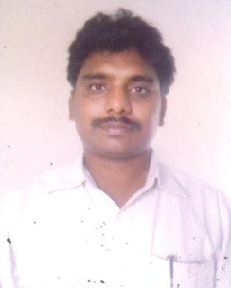Designation : ASSISTANT PROFESSOR

Department : **COMPUTER SCIENCE AND ENGINEERINGP**

1. Name : S.UMA MAHESWAR RAO
2. Date of Birth and Place of Birth : 31/07/1986
3. Address for Communication : roypet,narsapur
4. Permanent Address : roypet,narsapur
5. 5. Mobile No : 9948667699
6. Email-ID : saka.mahi@gmail.com
7. Educational Qualifications :M.Tech

|  |  |  |  |  |
| --- | --- | --- | --- | --- |
| **Qualification** | **University/Board** | **Name of the College** | **Specialization** | **Year of Passing** |
| **Ph.D** | Andhra university | Andhra university | Bigdata | pursuing |
| **PG** | JNT University, kakinada | GIET college,rajhamundry | CSE | 2009 |
| **UG** | JNTUH | TPIST college | CSIT | 2005 |
| DIPLOMO | S.B.T.E.T | SVKP COLLEGE | CSE | 2001 |
| **X Class** | Board of Secondary Education | ZPH school | -------- | 1994 |
| **Others** |  |  |  |  |

1. Teaching /Industry Experience : 13 years

|  |  |  |  |
| --- | --- | --- | --- |
| **S No** | **Designation** | **Organization** | **Total Exp. Years and Months** |
| **1** | ASSISTANT PROFFESOR | SWARNANDHRA | 10 years |
| **2** | ASSISTANT PROFFESOR | A.S.R.E.C.TANUKU | 2 years |
| **3** | ASSISTANT PROFFESOR | B.V.C.E.C,AMP ASSISTANT PROFESSOR | 1year |

1. Total Experience:

Teaching :13

Industry :0

1. Any other Distinctions/Achievements : ---
2. Research Papers Published in Journals :8
3. Research Papers Published in Conferences: 1
4. Citations: 16
5. Workshops/STTP Attended: 12
6. Workshops Conducted : 0
7. Details of Research Projects :------
8. Achievements :
9. Strengths : positive thinking,hardworking
10. Other Details if any :



Signature of the Candidate

1. Achievements :
2. Strengths :
3. Other Details if any :

Signature of the Candidate