**BIO-DATA**

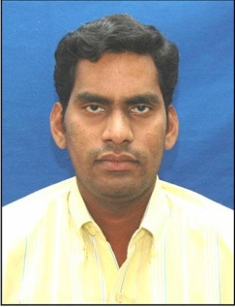Designation: ASSISTANT PROFESSOR

Department :**COMPUTER SCIENCE AND ENGINEERINGP**

1. Name : Mr. K.Rajesh Kumar
2. Date of Birth and PlaceofBirth :12-08-1977
3. AddressforCommunication : Podalada ,Razole ,EastgodavariDist
4. PermanentAddress : Podalada ,Razole ,EastgodavariDist
5. 5. MobileNo :9848466962
6. Email-ID :kumarkaligithi@gmail.com
7. EducationalQualifications :M.Tech

|  |  |  |  |  |
| --- | --- | --- | --- | --- |
| **Qualification** | **University/Board** | **Name of the College** | **Specialization** | **Year of Passing** |
| **PG** | JNT University, kakinada | AIET, Vizag | CSE | 2010 |
| **UG** | JNTUH | BVC,Odalarevu | CSE | 2004 |
| DCME | SBTE&T | TM Polytechnic college | DCME | 2000 |
| **X Class** | Board of Secondary Education | ZPPTH school | ------- | 1993 |
| **Others** |  |  |  |  |

1. Teaching/IndustryExperience :

|  |  |  |  |
| --- | --- | --- | --- |
| **S No** | **Designation** | **Organization** | **Total Exp. Years and Months** |
| **1** | ASSISTANT PROFFESOR | SCET | 14 years |
| **2** | ASSISTANT PROFFESOR | BVCITS | 2 years |
| **3** |  |  |  |

1. TotalExperience:

Teaching :16

Industry :00

1. AnyotherDistinctions/Achievements :
2. Research Papers PublishedinJournals :04
3. Research Papers PublishedinConferences: 03
4. Citations: 0
5. Workshops/STTPAttended: 25
6. WorkshopsConducted : 00
7. Details ofResearchProjects :---
8. Achievements : --
9. Strengths : positive thinking ,leadership
10. Other Detailsifany :

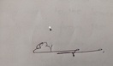

Signature of the Candidate